**PHASE V PROJECT**

**PROJECT TITLE:** PUBLIC TRANSPORT OPTIMIZATION

**TEAM NAME:** Proj_201030_Team_1

**NAME**: M.B.SAKTHI SELVA DEEBIKA

**REGISTER NUMBER**: 953021106058

**COLLEGE CODE**: 9530

**COLLEGE NAME**: ST. MOTHER THERESA ENGINEERING COLLEGE

**ABSTRACT:**

In this fast life, everyone is in hurry to reach their destinations. In this case waiting for the buses is not reliable. People who rely on the public transport their major concern is to know the real time location of the bus for which they are waiting for and the time it will take to reach their bus stop. This information helps people in making better travelling decisions. This paper gives the major challenges in the public transport system and discuss various approaches to intelligently manage it. Current position of the bus is acquired by integrating GPS device on the bus and coordinates of the bus are sent by either GPRS service provided by GSM networks or SMS or RFID. GPS device is enabled on the tracking device and this information is sent to centralized control unit or directly at the bus stops using RF receivers. People can track information using LEDs at bus stops, SMS, web application or Android application. GPS coordinates of the bus when sent to the centralized server where various arrival time estimation algorithms are applied using historical speed patterns. The project involves integrating IoT sensors into public transportation vehicles to monitor ridership, track locations, and predict arrival times. The goal is to provide real-time transit information to the public through a public platform, enhancing the efficiency and quality of public transportation services.

**INTRODUCTION:**

Public transport optimization refers to the process of improving the efficiency, reliability, and sustainability of public transportation systems. It involves using various strategies and technologies to enhance the overall performance of buses, trains, trams, subways, and other forms of public transit. Optimization efforts aim to reduce congestion, decrease travel times, minimize environmental impact, and enhance the overall passenger experience. This can involve route planning, scheduling, integration with other modes of transportation, and the application of data-driven solutions to make public transport more convenient and attractive to riders. Public transport optimization plays a vital role in addressing urban mobility challenges and promoting sustainable, accessible transportation in growing cities and communities.

**PROBLEM STATEMENT:**

Public transportation, such as buses, plays a vital role in the daily lives of people in urban and suburban areas. However, there are often challenges associated with the reliability and efficiency of bus services. Passengers frequently face uncertainties regarding the arrival and departure times of buses, leading to inconvenience and frustration. We don't have system which could inform Passenger about their Bus Timing. Schedule etc. We only do have record of bus Timings on which bus should start on a route which is also sometimes not followed by drivers. There is no information provided to passenger about buses. To address these issues, an IoT-based bus tracking system can be implemented.

**PROPOSED SOLUTION:**

The IoT-based bus tracking system will enhance the efficiency and reliability of public transportation, improve the passenger experience, and enable transit authorities to make data-driven decisions. This system will offer a comprehensive solution for real-time tracking, route optimization, maintenance, and passenger engagement. Develop a user-friendly mobile application for passengers to access real-time bus location information, estimated arrival times, route details, and notifications about delays or changes. Passengers can also use the app for ticketing and payments. Create a web-based dashboard for transit authorities and bus operators to monitor the entire fleet in real-time. The dashboard should provide insights into route efficiency, vehicle health, and passenger ridership data. It should also allow for route optimization and management.

BLOCK DIAGRAM:

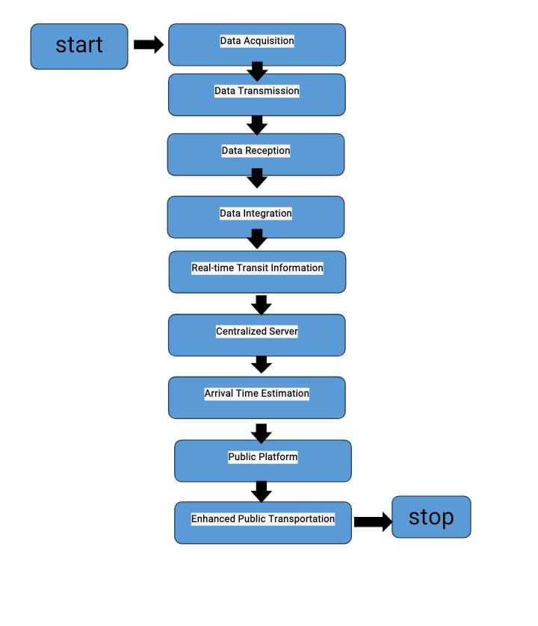

**COMPONENTS:**

IoT-based GPS tracking software is a software system that uses the Internet of Things and Global Positioning System (GPS) technologies to track the location of objects or people in real-time. The software collects data from GPS sensors, which are attached to the objects or people being tracked, and sends this data to a central server for processing. The server then uses this data to generate reports, maps, and other visualizations that allow users to monitor the location of their assets or personnel. This technology is commonly used in logistics and transportation, fleet management, asset tracking, and personal safety applications.

* GPS MODULE
* GSM MODULE

**GPS MODULE:**

The GPS module is a wireless chip module combined on the mainboard of a mobile phone or machine. It can communicate with the global satellite positioning system in the United States. The GSM network is an essential component of modern communication systems. It is a standard used by mobile devices to communicate with each other wirelessly. The GSM network provides a reliable and secure platform for communication, which makes it a preferred choice for many application.

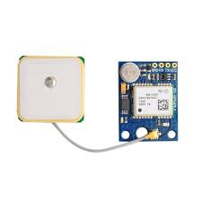

**GSM MODULE:**

A GSM module is a device that allows electronic devices to communicate with each other over the GSM network. GSM is a standard for digital cellular communications, which means that it provides a platform for mobile devices to communicate with each other wirelessly. The GSM module is a specialized device that enables a device to send and receive data over the GSM network.

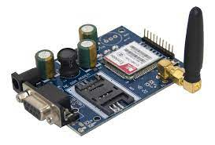

**WORKING:**

By using modern, GPS-enabled software systems combined with hardware like a tracking device installed within buses as well as apps installed on phones of users (e.g.drivers), a “real-time” bus tracking system can monitor the movement of buses on a map. Data such as the speed of the bus, the distance covered, the remaining distance to its destination, the number of scheduled stops (etc.) is received by Fleet managers in real-time. This helps them in taking any corrective action should there be any deviation or delays. An important part of bus-tracking is the school-bus segment since it is greatly beneficial for parents and school authorities to be able to monitor the safe transit.

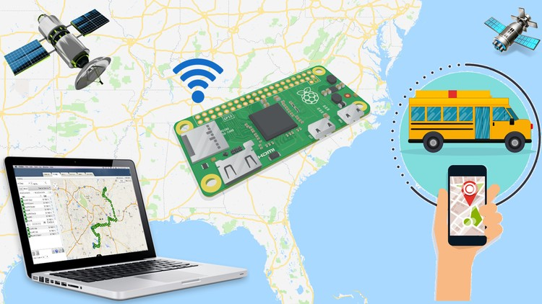 As the name indicates, a “real-time bus tracking system” tracks the movement and locations of buses traveling along various routes at different times and provides live data in “real-time” to a central control room. This helps Fleet Managers in the central location to monitor the progress of the buses i.e.whether they are traveling on pre-assigned routes, maintaining projected times, adhering to safety protocol while driving, making the prescribed number of stops (etc.).

Unfortunately, deviation from the planned routes and timelines are often necessitated due to issues like sudden traffic jams and inclement weather – these often cause delays and need buses to be re-routed. When such deviations occur e.g.when a bus either breaches the route prescribed, or its geofencing parameters or is taking longer than expected – the system alerts the Fleet Managers, who can take the required corrective actions in a prompt manner.

The GPS tracker present in the bus will be relaying information about its real-time location. The telematics device installed on the bus collects and transmits critical vehicle and driver data in real-time. The data is sent to central servers via cellular networks and GPS Satellite networks which will perform all computations and store each bus position in the database. This information stored on the cloud will then be retrieved by users through fleet management software or Android applications. These software and apps will display the real-time location of buses based on the user's destination graphically on the map.

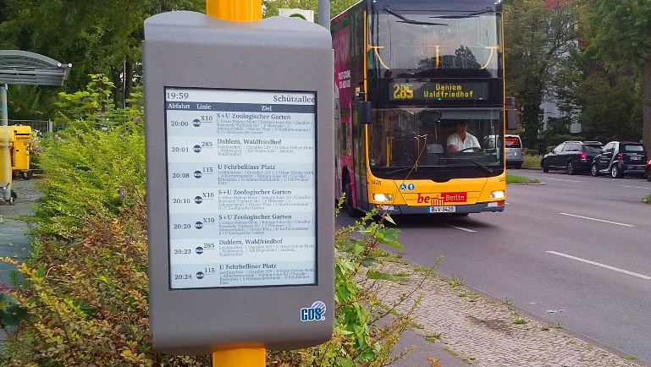

**SOURCE CODE:**

import time

import serial

import gpsd

from gsmmodem import GsmModem

# Define serial port for GPS communication

gps_serial = serial.Serial('/dev/ttyUSB0', 9600)

# Initialize GSM modem

modem = GsmModem(port='/dev/ttyUSB1', baudrate=9600)

modem.connect('<your_pin>', 'your_gsm_device')

# Function to send an SMS

def send_sms(message, recipient):

modem.sendSms(recipient, message)

# Function to get GPS coordinates

def get_gps_coordinates():

try:

packet = gpsd.get_current()

if packet.mode >= 2:

return packet.lat, packet.lon

else:

return None, None

except Exception as e:

print(f"Error reading GPS data: {e}")

return None, None

# Main loop

while True:

try:

command = input("Enter a command: ")

if command == "Track Vehicle":

lat, lon = get_gps_coordinates()

if lat is not None and lon is not None:

message = f"Vehicle Tracking Alert:\nYour Vehicle Current Location is:\nLatitude: {lat:.6f}\nLongitude: {lon:.6f}\nGoogle Maps Link: https://www.google.com/maps/@{lat},{lon},14z"

recipient = '850xxxxxxx' # Replace with the actual phone number

send_sms(message, recipient)

print("SMS Sent")

else:

print("No GPS Fix")

else:

print("Invalid command")

except KeyboardInterrupt:

print("Exiting")

break

# Disconnect GSM modem

modem.close()

**SOURCE CODE**

mapboxgl.accessToken = 'YOUR_MAPBOX_ACCESS_TOKEN'; // Replace with your Mapbox access token

const map = new mapboxgl.Map({

container: 'map',

style: 'mapbox://styles/mapbox/streets-v11', // You can use a different Mapbox style

center: [-73.981915, 40.747766], // Initial map center (longitude, latitude)

zoom: 12, // Initial zoom level

});

const busMarker = new mapboxgl.Marker()

.setLngLat([-73.981915, 40.747766]) // Initial bus location (longitude, latitude)

.addTo(map);

// Set up a function to update bus location (you would replace this with real-time data)

function updateBusLocation() {

// Replace with code to fetch real-time bus location data

// For this example, we're simulating a moving bus

const newLocation = simulateBusMovement(busMarker.getLngLat());

busMarker.setLngLat(newLocation);

requestAnimationFrame(updateBusLocation);

}

// Function to simulate bus movement (replace this with real real-time data)

function simulateBusMovement(currentLocation) {

// In this example, we're simulating bus movement by incrementing longitude

const newLongitude = currentLocation.lng + 0.0001;

return [newLongitude, currentLocation.lat];

}

updateBusLocation(); // Start updating the bus location

**SOURCE CODE**

<!DOCTYPE html>

<html>

<head>

<meta charset="utf-8">

<title>Real-Time Bus Tracking</title>

<meta name="viewport" content="width=device-width, initial-scale=1">

<link href="https://api.mapbox.com/mapbox-gl-js/v2.6.1/mapbox-gl.css" rel="stylesheet">

<script src="https://api.mapbox.com/mapbox-gl-js/v2.6.1/mapbox-gl.js"></script>

<style>

body {

margin: 0;

padding: 0;

}

#map {

height: 100vh;

width: 100%;

}

</style>

</head>

<body>

<div id="map"></div>

<script src="bus-tracking.js"></script>

</body>

</html>

**OUTPUT**

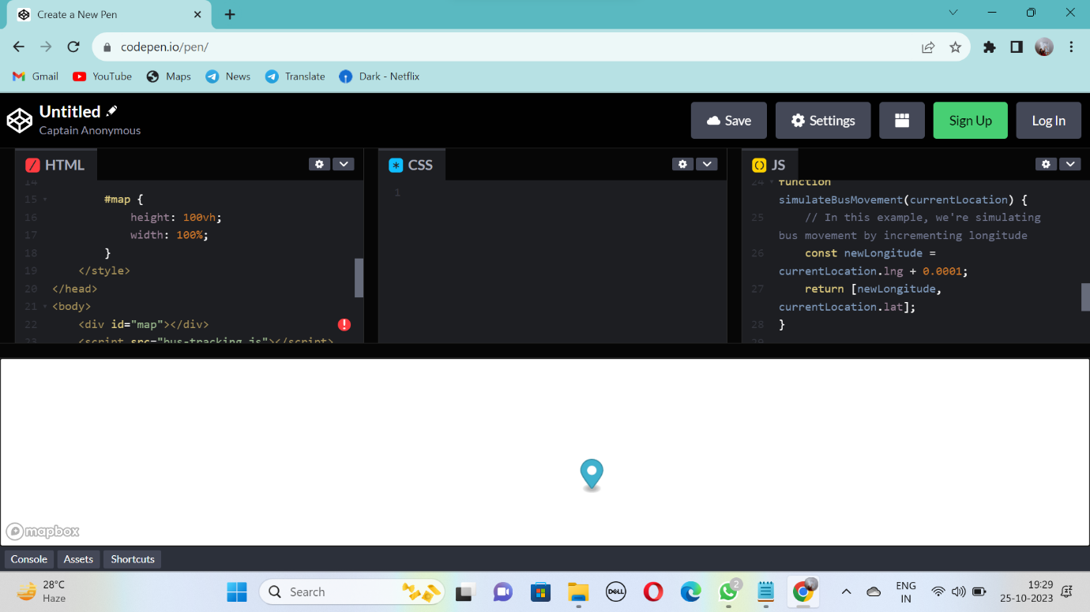

**PASSENGER EXPERIENCE:**

The passenger experience with real-time bus tracking is generally positive. It provides passengers with a sense of control and reduces uncertainty during their journeys. Passengers can make informed decisions, reduce waiting times, and adapt to changes in schedules or transportation options. However, it's important for service providers to ensure that the real-time tracking systems are accurate, reliable, and user-friendly to enhance the overall passenger experience.

**CONCLUSION:**

The real-time bus tracking is a valuable and transformative technology that significantly enhances the passenger experience in public transportation. This system provides numerous benefits to both passengers and transit authorities, making it an essential component of modern urban transportation networks. It has become a game-changer in the world of public transportation. It not only improves the passenger experience but also contributes to more efficient and sustainable urban transit systems. As technology continues to advance, we can expect real-time tracking to become even more integrated into public transportation networks, leading to further improvements in the overall efficiency and convenience of these services.